News from the UMBC SPIE Student Chapter
The SPIE Chapter of the University of Maryland Baltimore County had its annual meeting on July 17th. Dr. Sudhir Trivedi, a Fellow of the SPIE, Vice President and Chief Technology Officer at Brimrose Corporation of America, who is famous for his research for optical crystals and devices for sensors and detectors, was the Chief guest of the meeting. He was honored by the President of the Chapter Ms. Leslie Scheurer, a Ph. D. student of the Chemistry Department and Prof. Bradley Arnold, FRSC, the faculty advisor. He was honored with a plaque consisting of an acousto-optic crystal and a delay line of 200 μs fabricated using mercurous halde crystal. Prof. Brian Cullum, FSPIE, FOSA, Chairman, Chemistry and Biochemistry, Prof. Fow-Sen Choa, FSPIE, FOSA of the Computer Science and Electrical Engineering and Prof. N. B. Singh, FSPIE, FOSA, FASM , FRSC, of the Chemistry and Biochemistry and Computer Science and Electrical Engineering, and more than 25 students from several departments attended the meeting. The department of Chemistry and Biochemistry of the University provided the lunch for all the participants. Dr. Trivedi spent significant time to provide insight for the employments in optical industries and pathways for the growth in optics and photonics field. He insisted that this is a multidisciplinary field and students in from all departments are included in the national SPIE association.
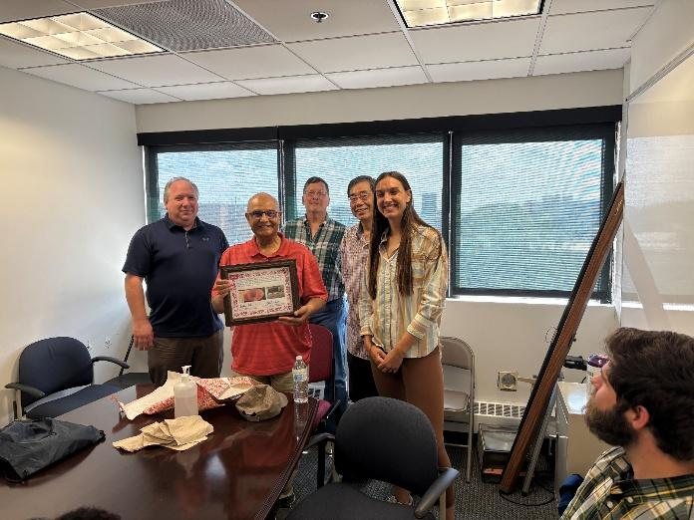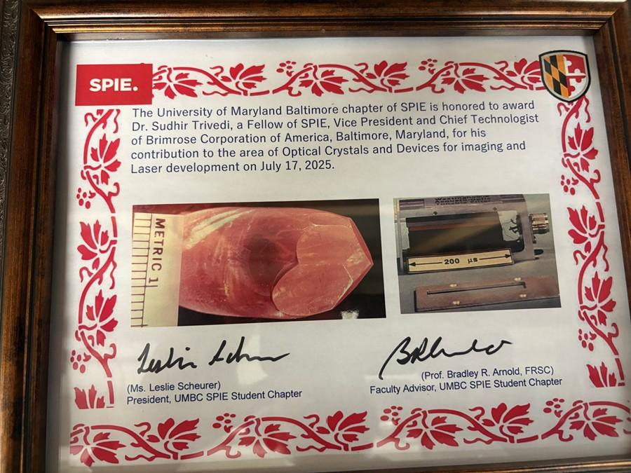
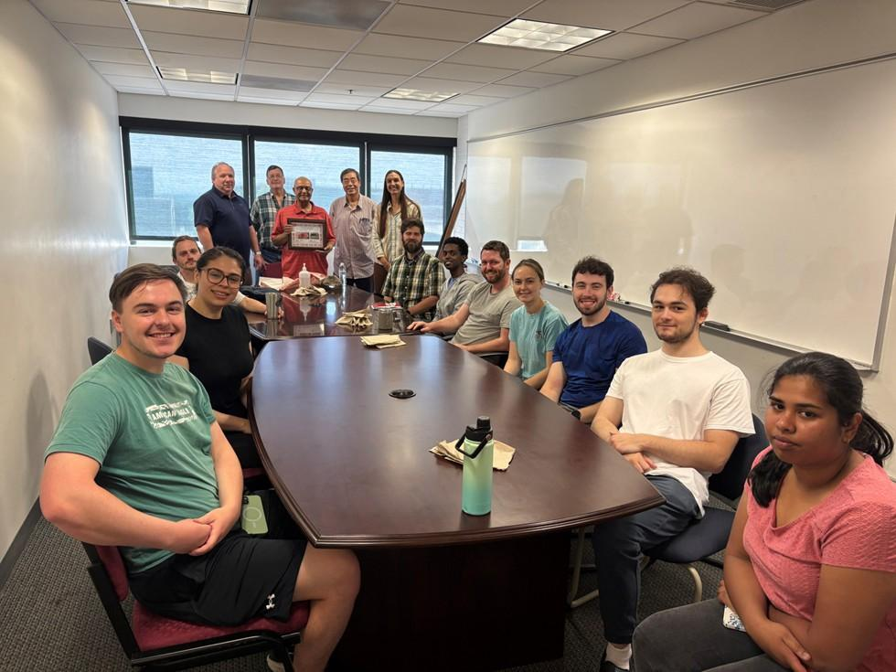
Dr. Sudhir Trivedi, FASM was honored by the President of local SPIE Chapter Ms. Scheurer and Faculty advisor Prof. Arnold in the chapter’s meeting.

